Program to implement CPU scheduling for first come first serve approach.

1. 1) FCFS with Arrival time.

Code:- import java.util.Arrays;

import java.util.Comparator;

import java.util.Scanner;

class Process {

int id;

int arrivalTime;

int burstTime;

int waitingTime;

int turnaroundTime;

public Process(int id, int arrivalTime, int burstTime) {

this.id = id;

this.arrivalTime = arrivalTime;

this.burstTime = burstTime;

}

}

public class FCFSWithArrivalTime {

public static void main(String[] args) {

Scanner scanner = new Scanner(System.in);

System.out.print("Enter the number of processes: ");

int n = scanner.nextInt();

Process[] processes = new Process[n];

for (int i = 0; i < n; i++) {

System.out.print("Enter arrival time for process " + (i+1) + ": ");

int arrivalTime = scanner.nextInt();

System.out.print("Enter burst time for process " + (i+1) + ": ");

int burstTime = scanner.nextInt();

processes[i] = new Process(i+1, arrivalTime, burstTime);

}

Arrays.sort(processes, Comparator.comparingInt(p -> p.arrivalTime));

int currentTime = 0;

for (Process process : processes) {

if (currentTime < process.arrivalTime) {

currentTime = process.arrivalTime;

}

process.waitingTime = currentTime - process.arrivalTime;

process.turnaroundTime = process.waitingTime + process.burstTime;

currentTime += process.burstTime;

}

System.out.println("\nProcess\tArrival Time\tBurst Time\tWaiting Time\tTurnaround Time");

for (Process process : processes) {

System.out.println("P" + process.id + "\t\t" + process.arrivalTime + "\t\t" + process.burstTime + "\t\t" +

process.waitingTime + "\t\t" + process.turnaroundTime);

}

double avgWaitingTime = Arrays.stream(processes).mapToInt(p -> p.waitingTime).average().orElse(0);

double avgTurnaroundTime = Arrays.stream(processes).mapToInt(p -> p.turnaroundTime).average().orElse(0);

System.out.println("\nAverage Waiting Time: " + avgWaitingTime);

System.out.println("Average Turnaround Time: " + avgTurnaroundTime);

}

OUTPUT:-

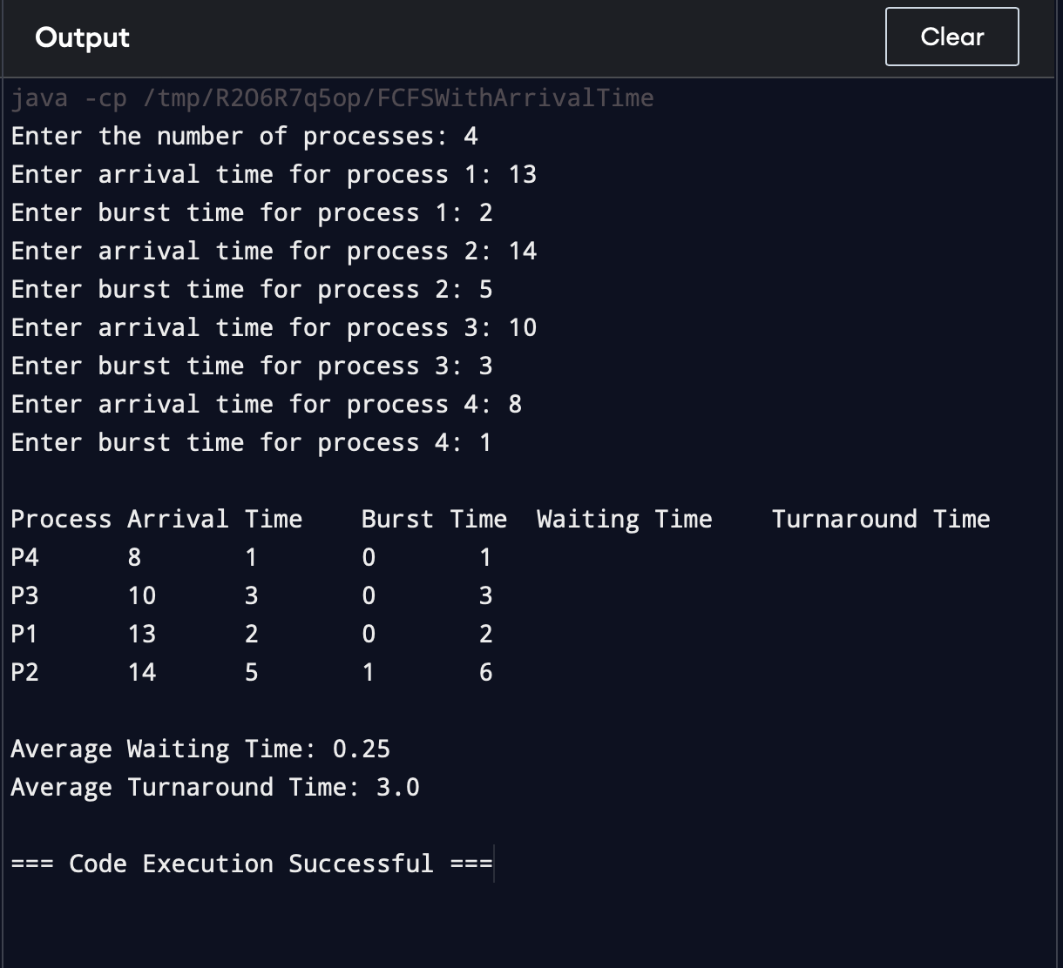

ii)FCFS without Arrival time

Code :-

import java.util.Scanner;

class ProcessNoArrival {

int id;

int burstTime;

int waitingTime;

int turnaroundTime;

public ProcessNoArrival(int id, int burstTime) {

this.id = id;

this.burstTime = burstTime;

}

}

public class FCFSWithoutArrivalTime {

public static void main(String[] args) {

Scanner scanner = new Scanner(System.in);

System.out.print("Enter the number of processes: ");

int n = scanner.nextInt();

ProcessNoArrival[] processes = new ProcessNoArrival[n];

for (int i = 0; i < n; i++) {

System.out.print("Enter burst time for process " + (i+1) + ": ");

int burstTime = scanner.nextInt();

processes[i] = new ProcessNoArrival(i+1, burstTime);

}

int currentTime = 0;

for (ProcessNoArrival process : processes) {

process.waitingTime = currentTime;

process.turnaroundTime = process.waitingTime + process.burstTime;

currentTime += process.burstTime;

}

System.out.println("\nProcess\tBurst Time\tWaiting Time\tTurnaround Time");

for (ProcessNoArrival process : processes) {

System.out.println("P" + process.id + "\t\t" + process.burstTime + "\t\t" +

process.waitingTime + "\t\t" + process.turnaroundTime);

}

// Calculate and print average waiting and turnaround time

double avgWaitingTime = 0;

double avgTurnaroundTime = 0;

for (ProcessNoArrival process : processes) {

avgWaitingTime += process.waitingTime;

avgTurnaroundTime += process.turnaroundTime;

}

avgWaitingTime /= n;

avgTurnaroundTime /= n;

System.out.println("\nAverage Waiting Time: " + avgWaitingTime);

System.out.println("Average Turnaround Time: " + avgTurnaroundTime);

}

}

OUTPUT:-

